SCBC Factory Tool Instruction for offline mode

Install
Turn on setup application
Example:

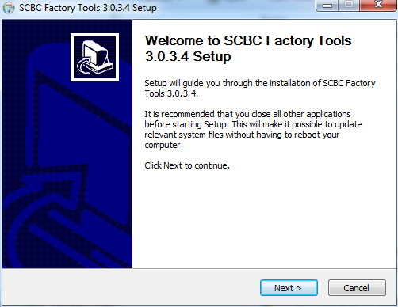
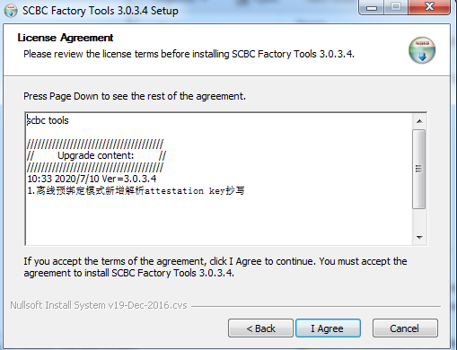

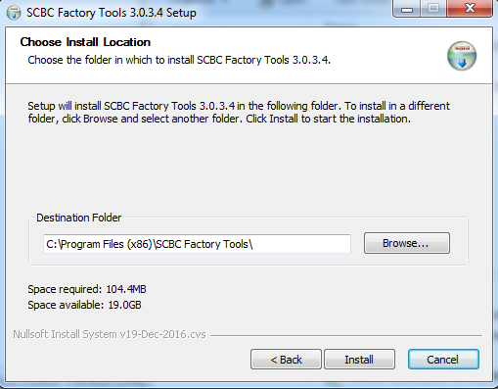
Runtime install
If it’s your first time installing and PC missing .Net4.5 runtime, software will install .Net4.5 first.
It will take a few minutes.

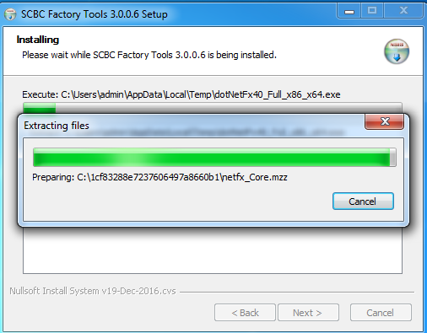
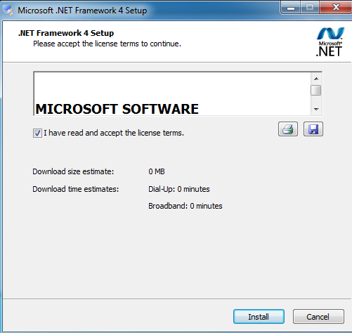
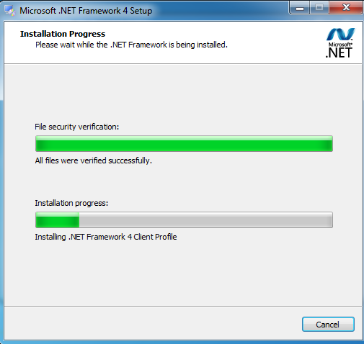
After install, it will create a shortcut on the desktop
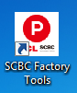

Login
If use offline mode, just input offline , offline as user and password.

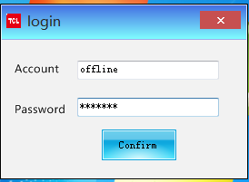

And ignore this message:
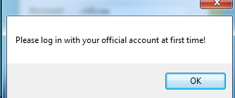

After login:
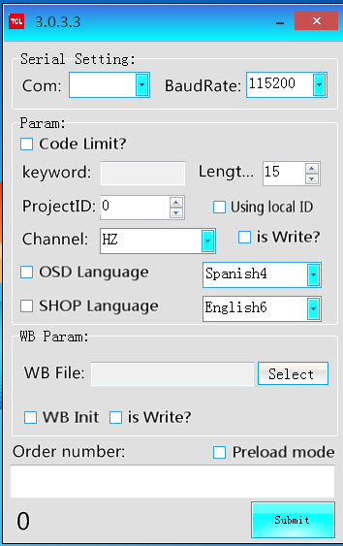

Load Key-DB file
Put the DB file into Keys folder.
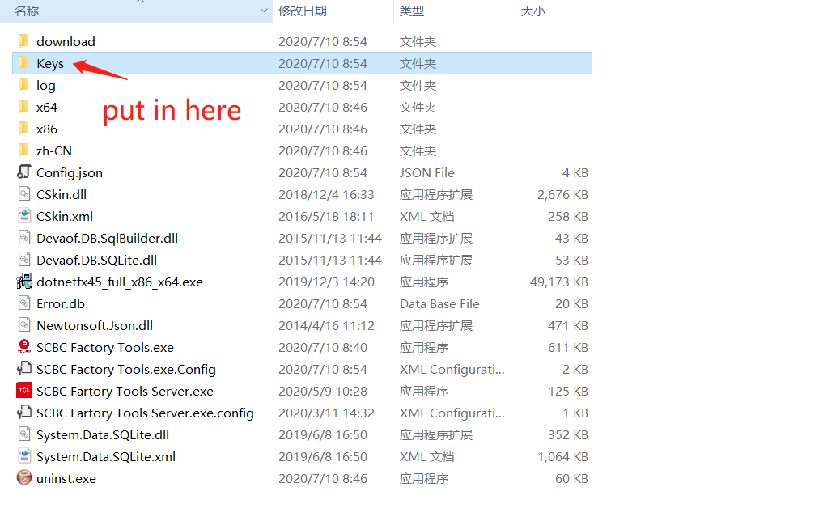
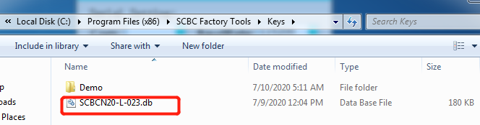

Config
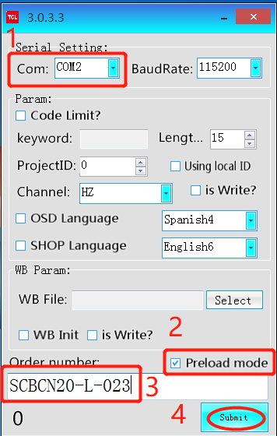

Select the Com port of TV

Click preload mode

Input the order name of the DB file

Click submit button
Then you can see the operate page and some basic message of the order:
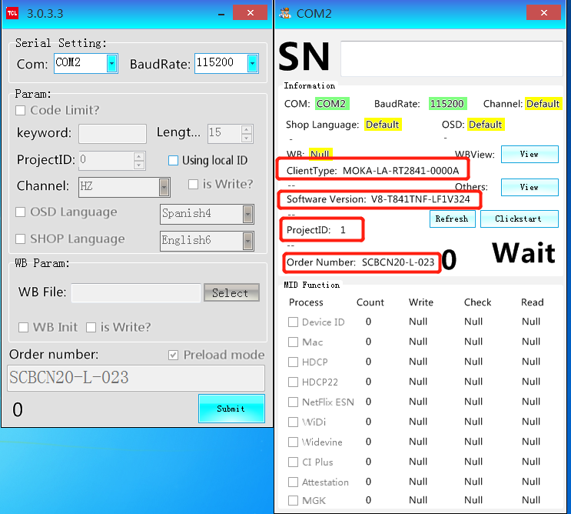

Testing
Focus on the testbox of SN, and scan the barcode of PCB, then it will trigger the testing.
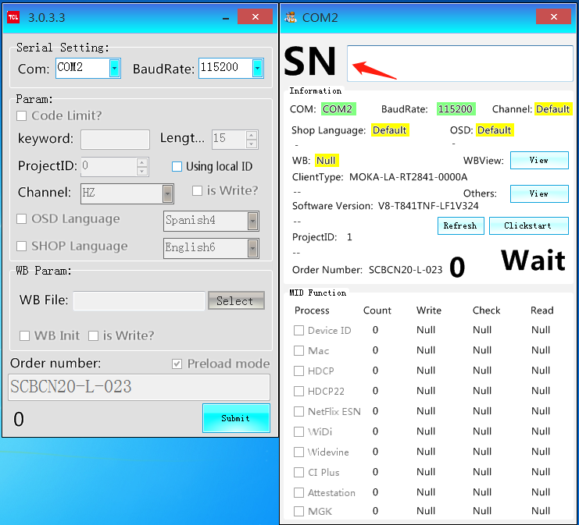
And you will see the burning key selected automatic.
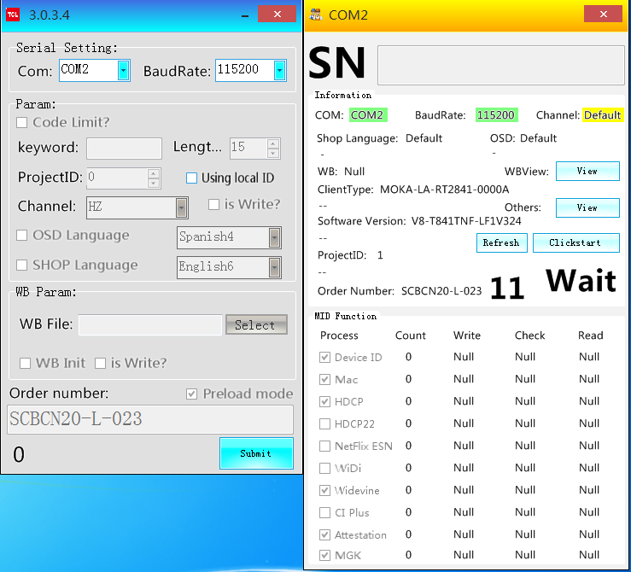

Special note
- Factory must provide the SN list of order before production, MID server system will distribute the keys depend on SN list and create the DB file. Then the factory tool will parse the DB file and burn the key into mainboard according to SN input from scanner.

- After finished the production, please send back the SN file to us for system record.

